ABSTRACT TITLE
(TIMES NEW ROMAN, 12 POINT, BOLD, CAPITAL LETTER, CENTERED)

Name Surname¹, Name Surname²
^{*1}University, Faculty, Department, City, Country- ORCID ID
² University, Faculty, Department, City, Country- ORCID ID

*Corresponding author e-mail:

ABSTRACT
The abstract should contain a maximum of 300 words, including the purpose and scope of the study, the material and method, and the main results of the study. The abstract should be written in single-spaced in 12 point Times New Roman. Page margins; should be set as 2.5 cm for top, bottom, left and right margins and paragraph spacing should not be added. The paragraph should not be indented. No figures and graphics should be added to the abstract text. All papers should be written in *.doc or *.docx format. Word File name should be written as Author Name_Surname. The abstract should be sent via the online submission system of conference web page.

Keywords: Minimum 3, maximum 5 keywords

1. INTRODUCTION

The introduction should present the scope and purpose of the article and state the problem, briefly review the relevant literature, describe the methods, and provide an overview of the main results of the study. The full text statement should not exceed 10 pages, including figures, graphics, references and abstract. The full text of research papers should consist of basic sections such as Abstract, Keywords, Introduction, Materials and Methods, Results and Discussion, and Conclusion and should be numbered consecutively. The main headings should be written in 12-point capital letters, with one line space at the top and bottom. The text should be justified and single-spaced 12pt Times New Roman font should be used. Paragraphs of text should not be indented and the spaces between paragraphs should be 1 line space.

2. MATERIAL AND METHODS

Methods and techniques such as experimental design, laboratory analysis, and statistical approaches should be clearly stated and explained with adequate references. Necessary details should be provided so that the study can be reproduced by other researchers. This section can be presented in more detail as sub-headings if desired.

2.1. Sub-heading

Sub-headings should be written in 12-point bold font, justified to the left, without indentation, with one line space left at the top and bottom, the initials of the words in capital letters and the rest in lower case.

3.RESULT AND DISCUSSION

The results of the study should be given clearly and discussed in detail, supported by the relevant literature.

4. CONCLUSION

The importance of the main results of the study should be emphasized, repetition should be avoided, and suggestions should be written if any.

ACKNOWLEDGEMENT

Supported institution, project, person, etc. information should be specified in this section. Acknowledgments to friends who are not among the authors of the paper and who contributed to the study can be expressed in this section. If the acknowledgment part is not necessary, this part of the paper may not be.

Tables and Figures

Tables and figures should be placed close to each other after their first source in the text. Tables and figures should be cited in the text. Figure titles and table titles should be sufficient to describe the figure or table. All figures and tables should be numbered as in the example below. Table headings should be centered above the tables. Figure caption should be centered below the figure as shown in Figure 1. Figure and table captions should be in Times New Roman font and 10 point font size. Each figure should be embedded in the main text. Figure resolution should be at least 300 dpi and presented in jpeg or tiff format. Figures and tables that are not referenced in the text should not be presented.

Table 1. Title of the Table (10 point)

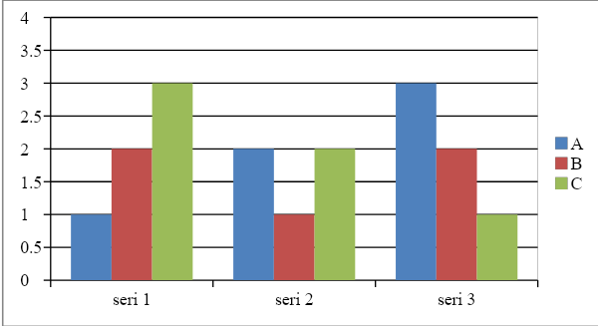
Figure 1.Title of the Figure

Equations, Symbols, Units and Abbreviations

Each equation should be presented on a separate line from the text, with spaces above and below. Equations should be clear and expressions used should be explained in the text. The equation number should be written in parentheses to the right of the equation. It should be specified as equation (1). Equations with pictures are not accepted. Standard abbreviations, symbols and units should be used; SI units are recommended. An example is given below.

d=-b±a22a | (1)
Care should be taken to ensure that the number and unit given in the main text are on the same line. Numbers should use a period as a decimal point (eg 0.10, 2.11, etc.). The thousands digit can be without or with a space (1000000 or 1 000 000).

REFERENCES

All citations in the text should be indicated by numbers in square brackets. The spelling as [1] refers to the first reference, the spelling as [1, 4, 5] refers to the publications numbered 1, 4 and 5, the spellings as [1, 2, 4-7] refers to the publications numbered 1, 2, 4, 5, 6 and 7. References should be added in Times New Roman and 11 point size. References writing formats are as follows:
Single-authored book or article
i. Book:
[1] Author Surname, First Name (publication year). Book Title. City of publication, publisher.
ii. Article:
[1] Author Surname, First Name (publication year). “Article Title”, Journal Title, Volume …, No…, p...
b. Book or article by two authors
i. Book:
[1] 1st author's surname, name and 2nd author's name and surname (year of publication). Book Title. City of publication, publisher.
ii. Article:
[1] 1st author's surname, name and 2nd author's name and surname (year of publication). “Article Title”, Journal Title, Volume …, No…, p..
c. Book or article with more than three authors
i Book:
[1] First author surname, first name et al. (Year of publication). Book Title. City of publication, publisher.
ii. Article:
[1] First author surname, first name et al. (Year of publication). “Article Title”, Journal Title, Volume …, No…, p...
d. Translation book
[1] Author surname, name (year of publication). Book Title. Translator name surname. City of publication, publisher.
e. Official or private publications, reports, etc., whose author is unknown.
[1] Report name (Year of publication). Institution name, City
f. Website
[1] Author surname, first name (Publication date). “Article title”, internet address (Date of access day month year).
g. Dissertation/Thesis
[1] Surname, First Name (publication year). Thesis Title. (Master's / Doctorate). City, University Name, Institute Name.

